SIMULATION EXPERIMENT – 1
1.Design, Realization and Performance Analysis of Butterworth IIR Low-Pass and High-Pass Digital Filters Using MATLAB
Objectives of this Experiment:
1. To design Butterworth IIR low-pass and high-pass digital filters for specified frequency requirements using MATLAB.
2. To obtain and verify the filter coefficients and determine the required filter order.
3. To plot and analyze the magnitude and phase responses of the designed filters.
4. To identify the cutoff frequency and examine the passband and stopband characteristics.
Program Code:

clear;
clc;
close all;

% Design Parameters
Fs = 8000; % Sampling frequency in Hz
Ap = 1; % Passband ripple in dB
As = 40; % Stopband attenuation in dB

% 1. Low-Pass Filter Design
fp_lp = 1000; % LPF Passband frequency (Hz)
fs_lp = 1500; % LPF Stopband frequency (Hz)
wp_lp = fp_lp / (Fs/2);
ws_lp = fs_lp / (Fs/2);

[N_lp, Wn_lp] = buttord(wp_lp, ws_lp, Ap, As);
[b_lp, a_lp] = butter(N_lp, Wn_lp, 'low');

% 2. High-Pass Filter Design
fp_hp = 2500; % HPF Passband frequency (Hz)
fs_hp = 1800; % HPF Stopband frequency (Hz)
wp_hp = fp_hp / (Fs/2);
ws_hp = fs_hp / (Fs/2);

[N_hp, Wn_hp] = buttord(wp_hp, ws_hp, Ap, As);
[b_hp, a_hp] = butter(N_hp, Wn_hp, 'high');

% ==========================================
% DISPLAY NUMERICAL OUTPUTS IN COMMAND WINDOW
% ==========================================
fprintf('=== EXPERIMENT 1: BUTTERWORTH IIR FILTERS ===\n\n');

fprintf('--- LOW-PASS FILTER ---\n');
fprintf('Calculated Filter Order (N_lp): %d\n', N_lp);
fprintf('3-dB Cutoff Frequency (Wn_lp): %.4f Hz\n', Wn_lp * (Fs/2));
fprintf('Numerator Coefficients (b_lp):\n');
disp(b_lp);
fprintf('Denominator Coefficients (a_lp):\n');
disp(a_lp);

fprintf('--- HIGH-PASS FILTER ---\n');
fprintf('Calculated Filter Order (N_hp): %d\n', N_hp);
fprintf('3-dB Cutoff Frequency (Wn_hp): %.4f Hz\n', Wn_hp * (Fs/2));
fprintf('Numerator Coefficients (b_hp):\n');
disp(b_hp);
fprintf('Denominator Coefficients (a_hp):\n');
disp(a_hp);

% Frequency Response Calculation
[H_lp, f] = freqz(b_lp, a_lp, 1024, Fs);
[H_hp, ~] = freqz(b_hp, a_hp, 1024, Fs);

% Plotting
figure('Name', 'Butterworth IIR LPF and HPF');
subplot(2,2,1);
plot(f, 20*log10(abs(H_lp)), 'b', 'LineWidth', 1.5); grid on;
title(['Butterworth LPF Magnitude (Order N = ', num2str(N_lp), ')']);
xlabel('Frequency (Hz)'); ylabel('Magnitude (dB)'); ylim([-80 5]);

subplot(2,2,2);
plot(f, angle(H_lp)*180/pi, 'r', 'LineWidth', 1.5); grid on;
title('Butterworth LPF Phase Response');
xlabel('Frequency (Hz)'); ylabel('Phase (degrees)');

subplot(2,2,3);
plot(f, 20*log10(abs(H_hp)), 'b', 'LineWidth', 1.5); grid on;
title(['Butterworth HPF Magnitude (Order N = ', num2str(N_hp), ')']);
xlabel('Frequency (Hz)'); ylabel('Magnitude (dB)'); ylim([-80 5]);

subplot(2,2,4);
plot(f, angle(H_hp)*180/pi, 'r', 'LineWidth', 1.5); grid on;
title('Butterworth HPF Phase Response');
xlabel('Frequency (Hz)'); ylabel('Phase (degrees)');

Output:
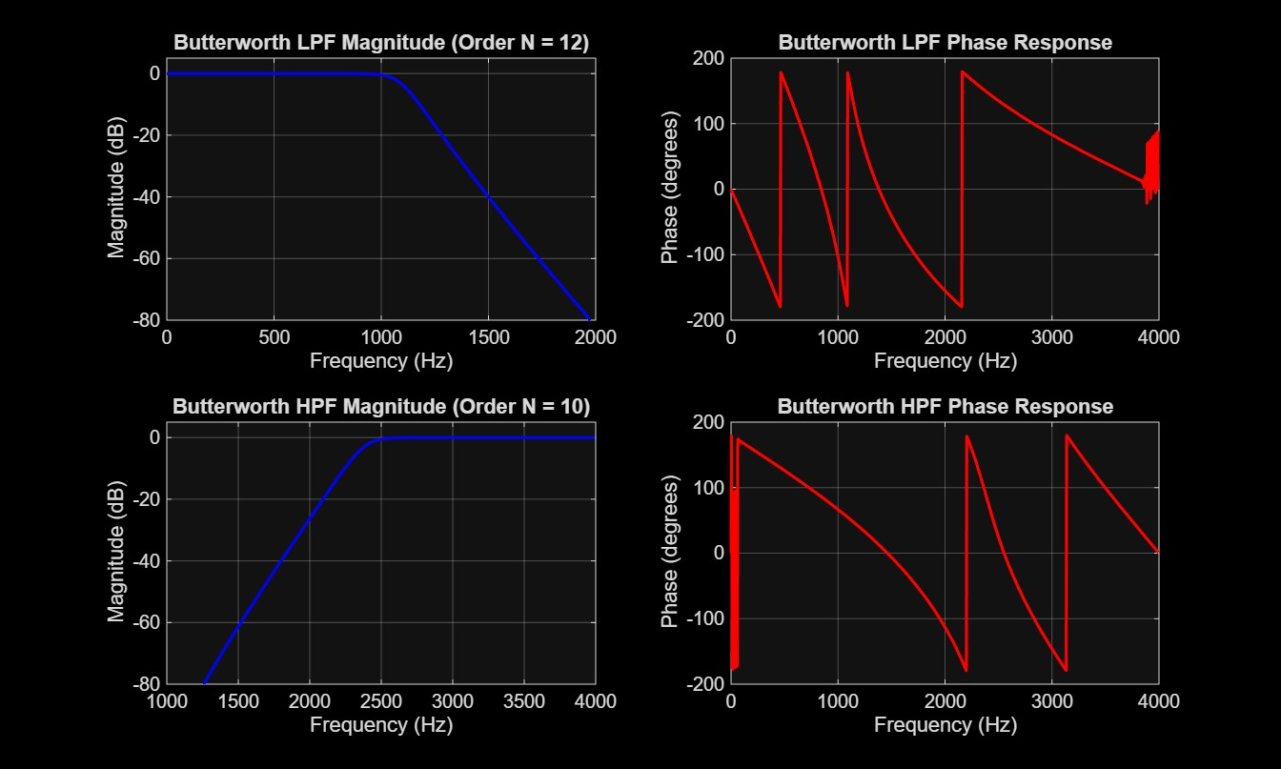
RESULT:
=== EXPERIMENT 1: BUTTERWORTH IIR FILTERS ===

--- LOW-PASS FILTER ---
Calculated Filter Order (N_lp): 12
3-dB Cutoff Frequency (Wn_lp): 1087.8354 Hz
Numerator Coefficients (b_lp):
0.0000 0.0000 0.0002 0.0006 0.0013 0.0021 0.0024 0.0021 0.0013 0.0006 0.0002 0.0000 0.0000

Denominator Coefficients (a_lp):
1.0000 -5.4622 14.6771 -25.1616 30.3497 -26.9537 17.9862 -9.0534 3.4018 -0.9283 0.1743 -0.0202 0.0011

--- HIGH-PASS FILTER ---
Calculated Filter Order (N_hp): 10
3-dB Cutoff Frequency (Wn_hp): 2379.7556 Hz
Numerator Coefficients (b_hp):
0.0006 -0.0055 0.0248 -0.0662 0.1159 -0.1390 0.1159 -0.0662 0.0248 -0.0055 0.0006

Denominator Coefficients (a_hp):
1.0000 1.8915 2.8535 2.6014 1.8704 0.9534 0.3726 0.1030 0.0199 0.0023 0.0001

>>

